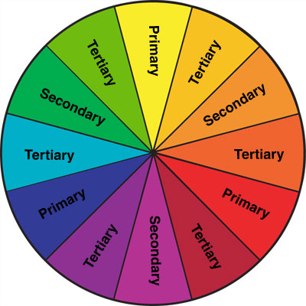**Complementary Colours**

**Complementary colours are colours that are**

**directly opposite each other on the colour wheel.**

**Instructions:**

**PRIMARY COLOURS: In each inner square paint a different primary colour. In each outer square, paint that colour’s complementary colour.**

**Primary:­­_________________ Primary:­­_________________ Primary:­­_________________**

**Complementary:­­_________________ Complementary:­­_________________ Complementary:­­_________________**

**SECONDARY COLOURS: In each inner square paint a different secondary colour. In each outer square, paint that colour’s complementary colour.**

**Secondary:­­_____________________ Secondary:­­___________________ Secondary:­­____________________**

**Complementary:­­_________________ Complementary:­­_________________ Complementary:­­_________________**