Shannon Jensen
Shannon Jensen travelled to South Sudan two years ago for what was intended to be a one week trip but was later extended to five. This 29 year old photographer wanted to bring global attention to the refugee crisis of South Sudan where 100,000’s of people, walked hundreds of miles to escape the war zone. She travelled to Blue Nile Region where she found 70,000 refugees and 30,000 descending on the valley. Shannon began photographing and interviewing subjects who were resting near a livestock watering hole. She recorded peoples’ stories of ‘burning houses, having to make the choice between leaving the elderly or children, walking past dead bodies and surviving on roots’. When she felt that enough information was gathered, Shannon sent her story to the publisher, however, no one was interested.
To get the attention of the public, she had to choose something simple yet effective, eye opening. While searching through her photos, Shannon came across a shot of a woman carrying three pairs of shoes. So, she decided to tell peoples story through their footwear.
Despite being thought crazy after photographing hundreds of shoes, she carried on, recording names, stories, ages of her subjects.
Her article was a huge success. Shannon Jensen currently splits her time between Washington and South Sudan.
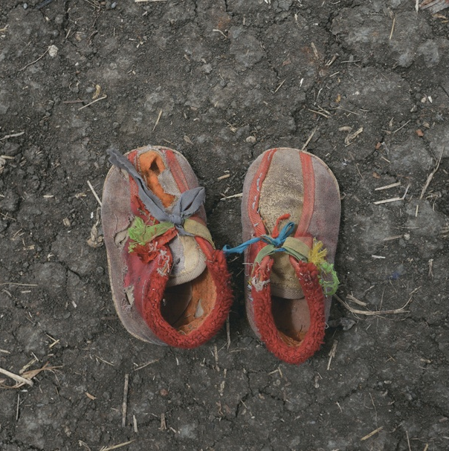
We followed up this project with one of our own. We made prints based on her photos of shoes, recorded basic information about the subjects and wrote some of our thoughts, as if in the situation of some of her subjects.
[Report by Shona Bassett, 2C]

