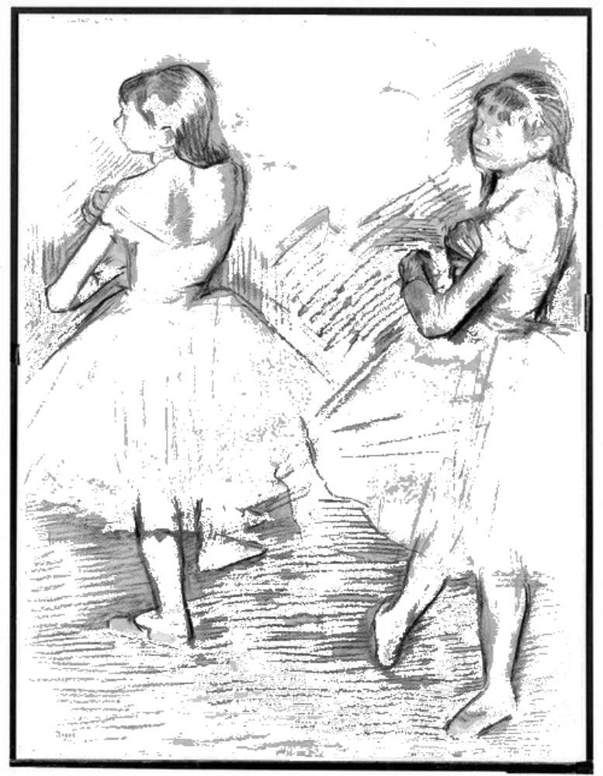

Impressionism

Impressionism - An ____ ________ and _______ of ________ that started in France during the ________.

It includes visible brush strokes, creating a sense of movement.

Impressionist artists tried to _______ glimpses of their _________ showing the effects of sunlight on things at different times of day.
art movement subjects painting style 1900’s paint

1860’s photography catch portraits still life

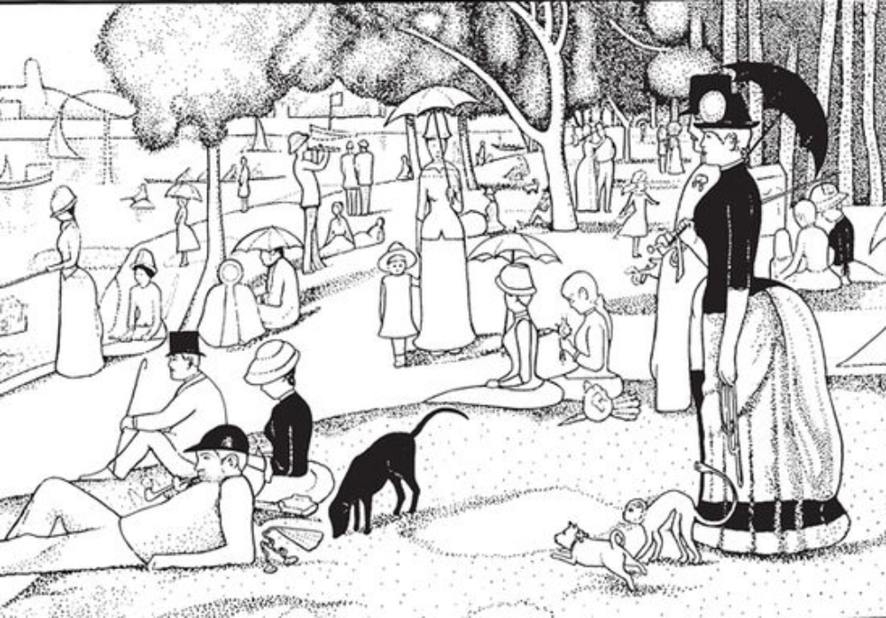

Pointillism

Instead of using brushstrokes to paint Pointillists put small _______ of colour on the paper.

Originally _______ paint was used for pointillist paintings as it was _______ and it didn’t run.

When we use this technique, we are mixing colours - not by _________ them together, but by placing two _______ side by side.
Colours Dots Squares Oil Thin Texture

Thick Tones Watercolour Blending Lines Shading

Pop Art
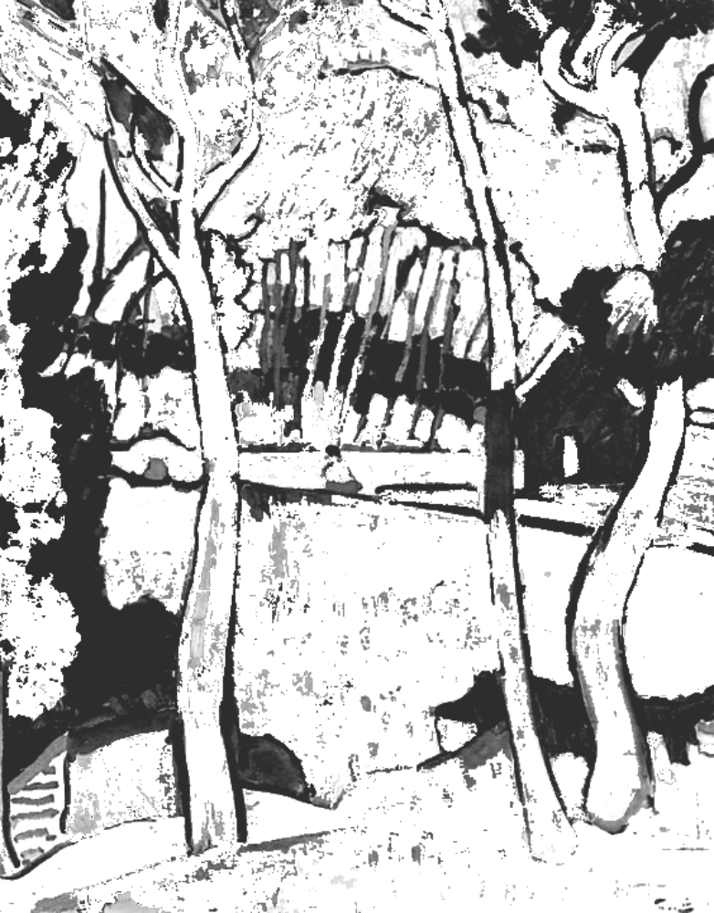

Fauvism

Movement in modern French painting. It uses very bold, ______ , pure colours.

The Fauves believed that a strong _____ pattern were more important than
being __________.

Their aim was to express _______through colour choice.

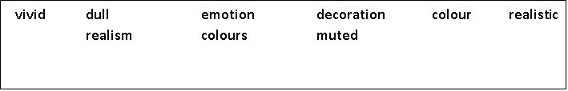

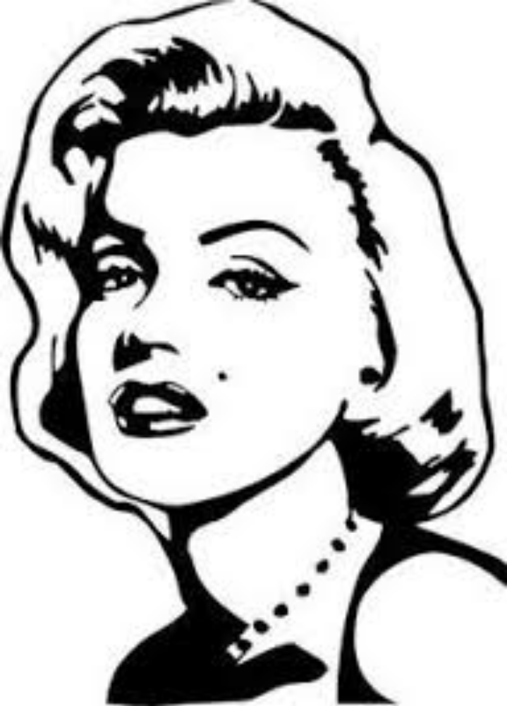

Short for _________ Art, the Pop Art movement used common _________ objects such as billboards, ___________ , magazine advertisements, famous faces and supermarket products.

Because it was influenced by ___________ and comic strips, it used bright ________ and flat colours. It also used thick _______ lines.

Another thing taken from advertising is the dots. The cheaper newspapers and magazines would blow photos up so much it would become ________.
Pop artists used this idea and added it into their art.

Popular Art Popcorn advertising household bold

television white black dotty comic strips stripey

